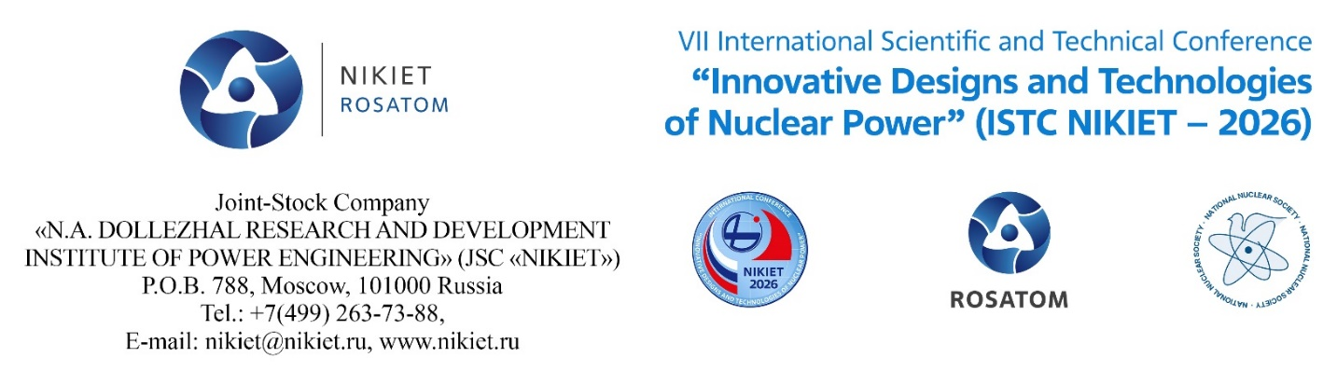

Third Information Letter
N.A. Dollezhal Research and Development Institute of Power Engineering, Joint-Stock Company (NIKIET JSC) sends out this invitation to take part in the Seventh International Scientific and Technical Conference “Innovative Designs and Technologies of Nuclear Power” (ISTC NIKIET – 2026), which will be held with the support of the State Corporation “Rosatom”, International Atomic Energy Agency and the Russian Nuclear Society on October 27-29, 2026.
CONFERENCE HIGHLIGHTS
CONFERENCE HIGHLIGHTS
1. Innovative designs of nuclear facilities for various applications (power, research (including molten salt one), etc.).
2. Nuclear fuel, coolants and new materials (including additive manufacturing).
3. Closed fuel cycle technologies, SNF and RW management, technological answers to the problems of non-proliferation.
4. Small size power reactors (stationary, floatable, transportable, propulsion, space).
5. New algorithms and codes for justifying designs and safe operation. Results of computational and experimental justifications of innovative designs
6. Fusion technology (controlled fusion, thermonuclear reactor, etc.).

7. Strength and reliability.

The Conference programme covers plenary sessions, section activities, poster presentations and round-table discussions on “Global Nuclear Power Development and Present Challenges”.

ORGANIZING COMMITTEE
Chairman – Andrey KAPLIENKO, Director General-General Designer of NIKIET JSC
Deputy Chairman – Igor TRETYAKOV (NIKIET JSC)
Executive Deputy Chairman – Boris GABARAEV (NIKIET JSC)
Address: 101000, Moscow, P.O.B. 788
Telephone: +7 (985) 991-17-08
E-mail: boris.gabaraev.iron@gmail.com
Secretaries – Igor KABANOV (NIKIET JSC)
Head of the International Projects Department
Address: 101000, Moscow, P.O.B. 788
Telephone: +7 499 263 7322
Email: int_corr@nikiet.ru
Elena BELAYA (NIKIET JSC)
Address: 101000, Moscow, P.O.B. 788
Telephone: +7 (499) 743-09-59
E-mail: int_corr@nikiet.ru
PROGRAMME COMMITTEE
Chairman – Evgeniy ADAMOV, Scientific Supervisor (NIKIET JSC)
Deputy Chairman – Aleksander LOPATKIN (NIKIET JSC)
Scientific Secretary – Aleksander DZHALAVYAN (NIKIET JSC)
Address: 101000, Moscow, P.O.B. 788
Telephone: +7 (499) 263-74-32
E-mail: int_corr@nikiet.ru
Head of Scientific Secretary’s Working Group – Elena LVOVA (NIKIET JSC)
Address: 101000, Moscow, P.O.B. 788
Telephone: +7 (499) 763-03-71, fax: +7 (499) 788-20-52
E-mail: int_corr@nikiet.ru

THE CONFERENCE WORKING LANGUAGES
The Conference working languages are Russian and English.
SUBMISSION OF ABSTRACTS AND FULL-LENGTH PAPERS
Abstracts no more than 1 page long shall be submitted to the Programme Committee
no later than July 24, 2026.
Full-length papers, shall be submitted to the Programme Committee no later than August 21, 2026.
Abstracts and full-length papers shall be submitted in English in electronic form (Microsoft Word). The presenters will download all their materials into their personal areas on the conference website (http://istc.nikiet.ru) after the registration. It is important that the total size of e-mail and attachments should not exceed 20 Mb. Where difficulties arise with the virtual personal area operations, the materials may be e-mailed to Boris GABARAEV, Executive Deputy Chairman of the Organizing Committee: boris.gabaraev.iron@gmail.com.
The format requirements for abstracts and full-length papers are attached (Annexes 1
and 2). The conference participants will receive the collection of abstracts upon arrival and registration at the NIKIET. The collection of reports is planned to be uploaded on CD and published on the conference website.
Presentations of all papers shall be in English and submitted to the Programme Committee (downloaded into their personal areas on the conference website (http://istc.nikiet.ru)) no later than October 5, 2026.

NIKIET JSC and the Conference Organizing and Programme Committees shall not be held responsible for any potential damage inflicted upon an organization or an individual in consequence of any information having been disclosed in an unauthorized manner as part of the materials provided in writing or verbally during the conference by its participants.
Full responsibility for such damage shall rest with the participant in the conference who has provided this information.

VENUE
NIKIET JSC, Academician Dollezhal Square 1, Moscow, RF
ORGANIZATIONAL AND FINANCIAL ISSUES
The applications for participating in the conference will be received until August 7, 2026 (with papers) and until September 18, 2026 (without papers).
The organizational fee is 900 Euro for each conference participant. Members of the Organizing and Programme Committees as well as university faculty staff, students and graduate students will be exempted from having to pay the organizational fee.
The fee payment covers organizational services (including the lunch and coffee breaks); simultaneous and consecutive interpreting; publication of the book of abstracts on paper, publication of abstracts and papers in the conference proceedings in electronic form (on a CD), publication of the conference proceedings on the NIKIET JSC official website and on the ISTC NIKIET – 2026 website; as well as the Krasnoselskaya metro station – NIKIET JSC transfers.
The organizational fee shall be paid to the bank account of NIKIET JSC (Bank details will be placed on the ISTC NIKIET – 2026 website at http://istc.nikiet.ru ). The payment by a plastic card on the conference days is also possible.
The online registration form for the participants, the conference information, the conference preliminary programme and the agreement form will be available on the ISTC NIKIET – 2026 website at http://istc.nikiet.ru and on the NIKIET JSC website at http://www.nikiet.ru.
Where difficulties arise with the online registration on the conference website, the application for the participation may be e-mailed to Boris GABARAEV, Executive Deputy Chairman of the Organizing Committee E-mail: boris.gabaraev.iron@gmail.com, telephone: +7 985 991 17 08
The application form is attached (Annex 3).

ABSTRACT FORMAT
Annex 1

Abstracts in English, no more than 1 page long (A4, 21×29.7 cm), shall be submitted to the Programme Committee no later than July 24, 2026 in electronic form (Microsoft Word).
The presenters will upload their abstracts into their personal areas on the conference website (http://istc.nikiet.ru ) after the registration. The online registration was opened on February 7, 2023. Where difficulties arise with the virtual personal area operations, abstracts may be e-mailed to Boris GABARAEV, Executive Deputy Chairman of the Organizing Committee: boris.gabaraev.iron@gmail.com.
General abstract text parameters:
Margins – all margins are 2.5 cm; common printable field dimensions are 16×24.7 cm.
Font – Times New Roman 12 pt.
Line spacing – single.
Abstract text arrangement on the page:
- paper title – semibold font, all capital letters, center alignment, space before 12 pt, space after 6 pt;
- authors – family name, initials, name of the organization, city, country: center alignment, space before 6 pt, space after 6 pt;
- abstract text – justified alignment, paragraph (first line) indent 1.2 cm.

No illustrations or references shall be attached to abstracts.
PAPER TITLE
Ivanov I., Frolov F. (NIKIET JSC, Moscow, Russia)
Petrovа P. (JSC GNC RF NIIAR, Moscow, Russia)
Sidorov S. (NRC Kurchatov Institute, Moscow, Russia)

This page is arranged to the required abstract format. This page is arranged to the required abstract format. This page is arranged to the required abstract format. This page is arranged to the required abstract format.

FULL-LENGTH PAPER FORMAT
Annex 2
Full-length papers in English (А4, 21×29.7 cm) shall be submitted to the Programme Committee no later than August 21, 2026 in electronic form (Microsoft Word).
The presenters will upload their papers into their personal areas on the conference website (http://istc.nikiet.ru ) after the registration. The online registration was opened on February 7, 2023. Where difficulties arise with the virtual personnel area operations, papers may be e-mailed to Boris GABARAEV, Executive Deputy Chairman of the Organizing Committee:
boris-gabaraev@yandex.ru.

General paper text parameters:
Margins – all margins are 2.5 cm; common printable field dimensions are 16×24.7 cm.
Font – Times New Roman.
Line spacing – single.
Page numbers – page bottom, center, 12 pt, ordinary font.

Paper text arrangement on the page:
- paper title – semibold 12 pt font, all capital letters, center aligned, space before 12 pt, space after 6 pt;
- authors – (family name, initials), name of the organization, city, country: 12 pt, center alignment, space before 6 pt, space after 6 pt;
- paper body – 12 pt ordinary font, full justification, paragraph (first line) indent 1.2 cm.
Possible headlines within the paper body:
- section headline: 12 pt, semibold font, left justification, space before and after 6 pt;
- subsection headline: 12 pt, italic, left justification, space before and after 6 pt;
- table heading: 11 pt, semibold font, center alignment, space before and after 6 pt;
- table number: 11 pt, italic, right alignment, space before and after 6 pt.
Figures and tables are placed in the paper body. Page, table and figure numbering is continuous. Table text – 11 pt, ordinary font. The table heading positions shall be as shown in the format example. The caption – 11 pt, italic, space after – 6 pt. There is no numbering for single figure or table in the paper, and no words Figure and Table shall be used in these cases while the caption, the table heading and references to them are obligatory.
The list of references shall be placed at the end of the paper and its format shall be in accordance with the general requirements for scientific and technical publications.
The references to tables, figures and literature within the paper body shall not be reciprocal (no Word editor tool shall be used).
Introduction and Conclusion shall be formatted as section headlines but shall not be numbered.
A paper body format example follows.
PAPER TITLE
Ivanov I., Frolov F. (NIKIET JSC, Moscow, Russia)
Petrovа P. (JSC GNC RF NIIAR, Moscow, Russia)
Sidorov S. (NRC Kurchatov Institute, Moscow, Russia)

Introduction

1. Section headline
1.1. Subsection headline
This page is arranged to the required full-length text format. This page is arranged to the required full-length text format. This page is arranged to the required full-length text format. This page is arranged to the required full-length text format. This page is arranged to the required full-length text format.
1.2. Subsection headline
This page is arranged to the required full-length text format. This page is arranged to the required full-length text format [1, 2]. This page is arranged to the required full-length text format (Fig. 1).
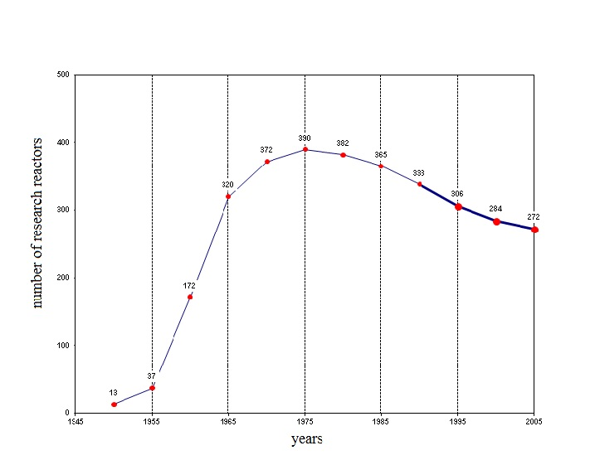
Fig. 1. Dynamics in the number of research reactors worldwide in 1945-2005
This page is arranged to the required full-length text format. This page is arranged to the required full-length text format.
2. Section headline
2.1. Subsection headline
This page is arranged to the required full-length text format (Table 1). This page is arranged to the required full-length text format.
This page is arranged to the required full-length text format. This page is arranged to the required full-length text format. This page is arranged to the required full-length text format. This page is arranged to the required full-length text format. This page is arranged to the required full-length text format. This page is arranged to the required full-length text format. This page is arranged to the required full-length text format. This page is arranged to the required full-length text format. This page is arranged to the required full-length text format. This page is arranged to the required full-length text format.

Table 1
Data on nuclear research facilities (NRF) worldwide [3]
Country | Number of NRFs built | NRFs in operation | NRFs  with W ≥ 1 MW,  in operation | RRs with W ≥ 15 MW,  in operation
Great Britain | 36 | 3 | 0 | 0
Germany | 46 | 13 | 4 | 2
India | 10 | 6 | 4 | 3
Canada | 19 | 10 | 4 | 1
China | 18 | 16 | 9 | 2
Republic of Korea | 4 | 2 | 1 | 1
Russia | 97 | 54 | 13 | 7
USA | 227 | 52 | 20 | 3

This page is arranged to the required full-length text format. This page is arranged to the required full-length text format (Table. 2).
Table 2
Table heading
Name of parameter | Quantity | Value 1 | Value 2 | Value 3
Parameter 1 | 10 | 3 | 0 | 0
Parameter 2 | 20 | 13 | 4 | 2

2.2. Subsection headline
This page is arranged to the required full-length text format. This page is arranged to the required full-length text format (Fig. 2).

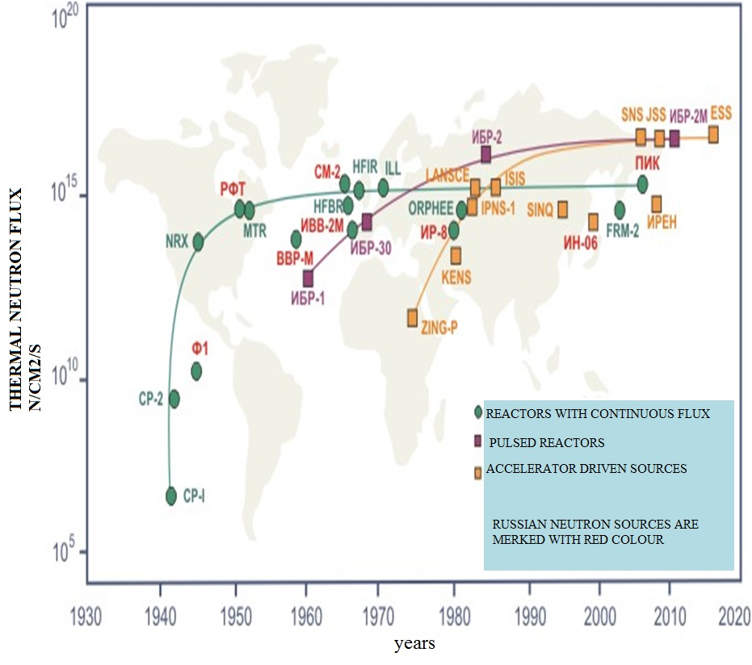
Fig. 2. Evolution of different neutron sources worldwide prior to 2020
This page is arranged to the required full-length text format. This page is arranged to the required full-length text format. This page is arranged to the required full-length text format. This page is arranged to the required full-length text format.
Conclusions
This page is arranged to the required full-length text format. This page is arranged to the required full-length text format. This page is arranged to the required full-length text format. This page is arranged to the required full-length text format. This page is arranged to the required full-length text format.
References
- Strength Analysis Code for Components and Pipelines of Nuclear Power Plants: Rules and Regulations in Nuclear Power (PNAE G-7-002-86). Moscow: Energoatom Publ., 1989. 25 p. (in Russian).
- Filatov V.M., Barsanov V.N., Evropin S.V. Reactor Irradiation Effects on the Cyclic Strength of Zirconium Alloys // Atomnaya Energiya. 1983. V. 55. Iss. 1. P. 29-31 (in Russian).
- Nuclear Research Reactors in the World. September 2000 Edition. IAEA, Vienna, 2000. 10 p.
- Keeping Tools Available for Future Nuclear Research in Europe / J. Guidez, D. Iracane, P. Ledermann, L. Martin. European Nuclear Conference ENC 2005, Versailles, France, 11-14 December, 2005. 10 p.
- IAEA Electronic Database on Nuclear Research Facilities, www.iaea.org/worldatom/rrdb/.

Annex 3

Application for the participation
in the Seventh International Scientific and Technical Conference

“Innovative Designs and Technologies of Nuclear Power”

(ISTC NIKIET – 2026) October 27-29, 2026

Family Name
First Name
Country
Post Address
E-mail
Organization
Paper (if any)
Paper authors
Reporter Name
Name of organization (abbreviated)
I hereby grant my consent to the posting of my presentation on the conference website | Yes | No
I intend to stay throughout the conference | Yes | No
I intend to stay only on certain days of the conference (specify dates)
Organizational fee payment method*  (choose one option) | Transfer to the account based on a contract  Transfer to the account without making a contract  Payment by plastic card on the conference day
* University faculty staff, students and graduate students will be exempted from having to pay the organizational fee.

